William Renard

Julie Sakai

Tazmin Somerville

Tatiana Tan

Paul Romer

Group 4

CSD460

# Module 6 Assignment

Landing page



Login page

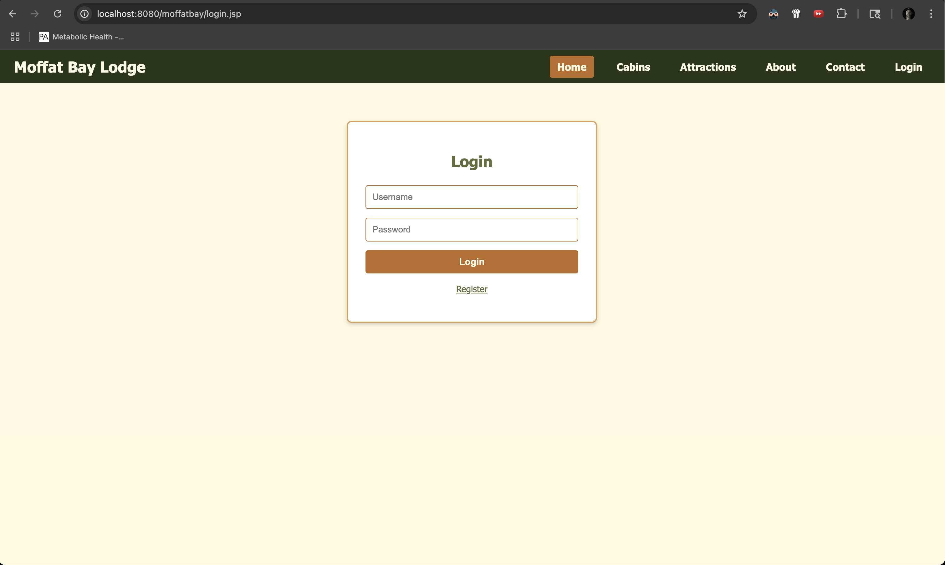

Registration page

